Energy requirement for continuous ethanol extraction via pervaporation and/or distillation at low concentrations

Matt Williams
Master of Engineering Candidate
May 3, 2013

1. Introduction
Syngas fermentation, or synthesis gas fermentation, is a microbial process that uses hydrogen, carbon dioxide, and carbon monoxide to produce fuel. The effluent in this process contains low concentration ethanol, which often ranges from 2 to 6 wt% ethanol. To make this ethanol usable, it must be concentrated to >95 wt% to be considered fuel grade ethanol. Most commonly, distillation is used to produce fuel grade ethanol, however this requires too much energy for low concentration ethanol feed streams.

Most industrial processes use a combination of distillation and a dehydration technique to separate water-ethanol mixtures in order to use it as a fuel. The first step in the industrial process involves distilling the feed stream to its azeotrope. An azeotrope is a mixture of two liquids whose components cannot be altered by simple distillation. For an ethanol-water mixture, the azeotrope occurs at 95.63% (w/w), which means that once this mixture is distilled to this point, additional distillation cannot increase the weight percent of ethanol in the mixture. Fixed-bed absorbents, such as hydrophilic molecular sieves, are mostly used to remove the remaining water in the mixture; however, these sieves are expensive and have to be replaced after they are saturated with water [7]. The use of distillation and molecular sieves requires a relative large amount of energy to produce fuel grade ethanol, especially for low concentration ethanol on small scale. Figure 1 below shows the energy required to recover fuel grade ethanol from distillation on an industrial level. Once the feed concentration drops below 5 wt%, the energy required to distill increases exponentially as feed concentration decreases. Therefore, there exists a need for an energy efficient process for converting low concentration ethanol feed streams to fuel grade ethanol.
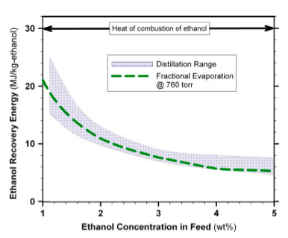
Figure 1. Energy required to recover ethanol from an ethanol-water mixture by distillation as a function of ethanol concentration in the feed [9]

2. Objectives
Various different methods for reducing the energy required to produce high concentration ethanol were analyzed for their conceivable ability to decrease energy consumption. Additionally, the feasibility of using each method on the pilot scale was also taken into consideration. Among the separation techniques analyzed were distillation with heat pumps, vacuum distillation, gas or steam stripping, and pervaporation. Preliminary research was performed and it was determined that the process that had the most potential to decrease the amount of energy required to recover ethanol was a hybrid distillation-pervaporation system. Since the feed stream is as such a low concentration, it will first be concentrated via a pervaporation module and then it will be distilled to its azeotrope by fractional distillation. A model will be made for a system that produces an ethanol-water effluent from a syngas fermenter that uses distillation alone to produce 95 wt% ethanol in the distillate. Then, a model will be made for a system where the syngas fermentation effluent is first concentrated via a pervaporation module and then distilled. The flow rates in both models will be calculated to find the amount of ethanol recovered in grams per hour. Then, the amount of energy required per hour will be calculated for both models and an analysis will be done to compare the energy required to recover a gram of ethanol for various feed stream concentrations.

3. Materials and Methods

3.1 Pervaporation Overview
Pervaporation is a separation technique in which a liquid with multiple components undergoes partial vaporization and is separated by a polymeric membrane. There has been a lot of interest in this as a separation process because of the high separation efficiency and potential energy savings associated with it. The name of this technique comes from the fact that the liquid mixture goes through both permeation and evaporation. The liquid mixture feed is first brought into contact with the membrane where one of the components of the mixture is preferentially removed from the feed due to a higher affinity for the polymer membrane, which increases its diffusivity in the membrane [4]. A chemical potential then causes the mixture to transition into the vapor state, which permeates through the membrane by diffusion. This vapor permeate is then condensed back into a liquid after pervaporation.

Pervaporation is commonly used for the dehydration of azeotropes such as water-ethanol mixtures. The distillate is used as the feed stream for the pervaporation module and depending on the type of membrane used, 99 wt% can potentially be achieved as the end product. In these alcohol dehydration plants, the feed stream going into the distillation column is usually around 10 wt% and the product goes through several distillation steps to get it to its azeotrope. Pervaporation as a method of dehydration is usually only energetically efficient when the feed stream for the pervaporation module is less than 10 wt% water. For this model, pervaporation will be used before distillation as a way of concentrating the ethanol stream before it is distilled. Pervaporation can be run either in batch or continuously. One major distinction in pervaporation system design is whether the pervaporation modules work in continuous or batch modes. In a continuous system, a continuous feed stream flows to the pervaporation module and both retentate and permeate streams are continuously removed from the module. For the continuous system, pervaporation can be used as a stand-alone system or can be used in a hybrid distillation-pervaporation system. In a batch system, a feed tank holds the sample that is to be run through the pervaporation membrane and the retentate is recycled back to the feed tank until a certain concentration is reached in the permeate. This system is simpler to use, however it is harder to use on an industrial scale. In this designed hybrid distillation-pervaporation system, the feed stream will be fed in a continuous mode. Since the fermenter will have media constantly flowing in and a feed stream of an ethanol-water mixture coming out in the effluent, it makes more sense to design the system in a continuous method rather than waiting for a certain amount of effluent to be collected from the fermenter.

The driving force for pervaporation is the difference in chemical potential between the components in the feed and permeates sides [1]. This difference in chemical potential can be achieved by creating a difference in partial pressures by reducing the total pressure on the permeate side using a vacuum. Another method of creating the vapor pressure gradient is by creating a temperature gradient so that the vapor permeate is driven out by condensation. A sweeping gas could also be flowed over the permeate side of the membrane to create the chemical potential to drive the flux across the membrane. For the purposes of this application of pervaporation, a vacuum will maintain a decreased pressure on the permeate side of the membrane, creating the permeate flux. Pervaporation is unique among separation processes because the phase change from liquid to vapor state occurs across the membrane [2]. The following graphic in figure 2 shows the mechanism of mass transfer. One of the components is selectively absorbed onto the feed side of the membrane, it then diffuses through the membrane, and then desorbs into a vapor phase on the permeate side of the membrane. The permeate side of the membrane is maintained at a low enough pressure so species on this side are in the gaseous phase.
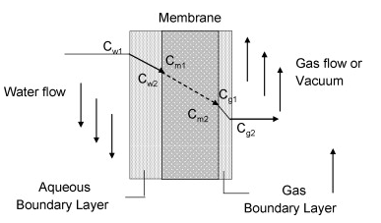
Figure 2. Concentration profile across a pervaporation membrane where C_{w} is the aqueous concentration, C_{m} is the membrane concentration, and C_{g} is the gaseous concentration [2]

The membrane in the pervaporation module can be either organophilic meaning that it would select for organic compounds, or hydrophilic, which would select primarily for water. One of the most common current uses of pervaporation is as a method of dehydration after another initial separation process. The membrane type should be carefully chosen so that the membrane selects for the component with the smallest weight fraction in the mixture. This minimizes the flow across the membrane, which will prevent membrane fouling, which would significantly decrease the performance of the separation. To concentrate the ethanol-water mixture and minimize flux through the membrane, an organophilic membrane will be used in the pervaporation module.

The performance of a specific pervaporation system is based on the permeate flux and selectivity of the membrane. Permeate flux is dependent on the maximum pressure drop allowed by the membrane and the total area of the membrane. If the membrane allows for a larger pressure drop, then the chemical potential gradient will also be larger, which will increase the flux across the membrane. The temperature of the liquid mixture before it interacts with the pervaporation membrane is also a critical factor in the separation since increasing the temperature of the feed increases diffusivity and reduces viscosity. However, there is a maximum temperature at which the feed can be heated to or else the integrity of the membrane can be compromised. The temperature dependence follows the Arrhenuis equation and flux usually doubles with a temperature increase of 10-12 K [4].

The selectivity of the pervaporation membrane can be evaluated using the separation factor and enrichment factor. The separation factor of a membrane is defined in the following equation:
$$α=\frac{{({C_{i}}/{C_{j}})}_{Permeate}}{{{(C_{i}}/{C_{j})}}_{Feed}}$$
In this equation, C_{i} is the concentration of the component that is the membrane preferentially selects for and C_{j} is the concentration of the component with the lower volatility that isn’t being selected for [3]. Another factor used to evaluate selectivity is the enrichment factor:
$$β=\frac{{(C_{i})}_{Permeate}}{{\left(C_{i}\right)}_{Feed}}$$
Both the separation and enrichment factors are strongly dependent on the feed composition. The chemical composition of the membrane strongly influences how effective the separation is of the components of the feed liquid and can change the selectivity factor of the membrane. Also, the component that is being selected for can change both the enrichment and separation factors. Each polymeric membrane has different interactions with different molecules, so a membrane that has a high selectivity for ethanol may have the same selectivity for butanol. For the separation of ethanol from water, zeolite membranes have the highest selectivity and perform much better than other polymeric membranes [9]. However, these membranes are very expensive and are not cost effective for pilot scale uses.

Another factor that affects the performance of the membrane is the actual design of the membrane. There are two main designs: plate-and-frame and spiral-wound. In the plate-and-frame module, the plates and feed channels are made using stainless steel, which support the membranes that the feed flows through. Spacers are used to create the permeate channels and are open on all sides of the plates so that the maximum amount of permeate can be removed [6]. The arrangement of the plates and the feed channels allows for uniformly spaced flow across the membranes. An advantage of these modules is that additional plates and membranes can be added on, so they are more easily customizable when a certain permeate flux is required. The other commonly used pervaporation module is the spiral-wound design, as seen in figure 3. In this design, flat sheets are arranged in a cylindrical formation with membrane between the feed spacer sheets. There are also permeate spacers to allow for adequate fluid flow for the permeate. The permeate flows through all the membrane layers to the center of the module and flow out the permeate end. This design is more compact than the plate-and-frame model and is mainly used for organic extraction [6]. For this application of pervaporation, a spiral-wound module will be used since ethanol is the compound that is being extracted and these work especially well with low concentration organics.

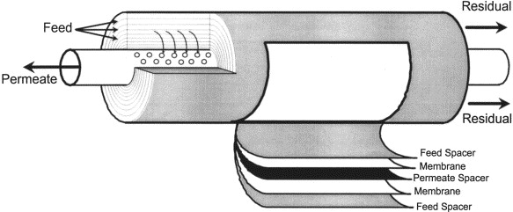
Figure 3. Schematic of a spiral-wound pervaporation module [6]

One method to increase the performance of a pervaporation membrane that will be used is recycling the retentate back to the inlet of the membrane. Since the liquid that flows over the membrane needs to be in turbulent flow when it interacts with the membrane, it is sometimes necessary to increase the flow in a recycling loop. Creating turbulent flow allows for more of the liquid to interact with the entire surface area of the pervaporation membrane so that flux can be maximized. The ratio of recycled liquid to permeated vapor can be changed to try to find the optimal balance between the additional energy required used by the pump and the increase in membrane flux [5].

Processes that involve the phase change of all components of a liquid mixture, such as distillation, are very energy intensive. Pervaporation is an energy saving alternative to this because only the minor component of the mixture goes through a phase change instead of all of the mixture. Compared to distillation, only a fraction of the feed that diffuses through the membrane consumes latent heat [4]. This is achieved because of the selective membrane increases diffusivity and solubility for ethanol decreases the amount of water that is transported across the membrane.

3.2 Distillation Overview
Distillation, which is part of almost every system that produces high concentration ethanol, consists of boiling a mixture in a closed system and condensing the vapors back to a liquid. The theory behind this technique is that the more volatile component, in this case ethanol, will boil more easily and the vapors will rise to the top of the still, where they can be collected. The source of energy to drive the process most often comes from a reboiler that is below the column. Often some of the product is refluxed back to the distillation column to provide additional heat and enrich the product even further. Figure 4 below shows a general schematic of a distillation column. The most basic form of distillation is simple distillation. The ethanol-water mixture is heated and vaporized in an empty distillation column and the distillate is collected at the top and condensed. This is a very ineffective method in that the distillate collected will not be very pure.
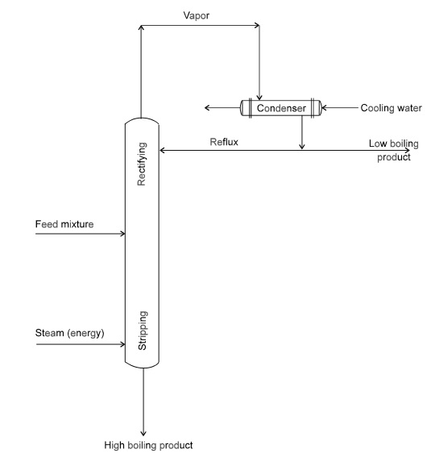
Figure 4. Schematic of an ideal distillation column [10]

Fractional distillation has been developed to recover more enriched ethanol in the final distillate. In this method, a column can either be packed with a packing substance or there can be a series of trays throughout the column. In both cases, the objective is to increase the separation by repeated vaporization-condensation cycles. When the feed stream heats up and vaporizes, it rises and cools then it condenses on either a tray or packing material. The condensate continues to be heated by rising hot vapors, which causes it to vaporize again. Each time the distillate goes through a vaporization-condensation cycle the vapors become more enriched. The more packing material or trays that are present increases the surface area for the vapors to condense on, which will increase the final concentration of the product. The distillation column used in the model is a well-packed column that is able to produce 95 wt% ethanol.

Distillation, similarly to pervaporation, can either be operated in batch or continuous use. In batch distillation, the entire feed that is to be distilled is put in the bottom of the distillation column. The distillation is run until the concentration in the bottom of the still decreases to a certain level, then the distillate that is collected can be run through the distillation column again. In continuous distillation, feed is constantly added to the distillation column as distillate is drawn off. Batch distillation requires less of a capital investment and has more operational flexibility, however, it is more energy intensive [10]. For this model, continuous distillation will be used to decrease the energy cost.

3.3 Model for Distillation System
The first system uses only distillation to enrich the low concentration ethanol feed stream to 95 wt% ethanol. As seen in figure 5 below, an initial feed stream of media flows into the syngas fermenter at point 1 and the fermenter has an initial ethanol production rate in grams per hour. The effluent then flows out of the reactor at point 2 and is pumped into the middle of the fractional distillation column. The ethanol feed stream is continuously distilled and the distillate is collected at the top of the column. At the bottom of the still, a bottoms stream at point 3 removes low concentration ethanol, which is assumed to be 0.25 wt% ethanol [10]. The purpose of the bottoms stream is to maintain a high enough concentration of ethanol within the still. If the weight percent of ethanol within the distillation column becomes depleted, the energy required to distill the feed stream per gram of ethanol recovered will increase rapidly. The distillate stream at point 4 will then be condensed back into the liquid state and recovered.
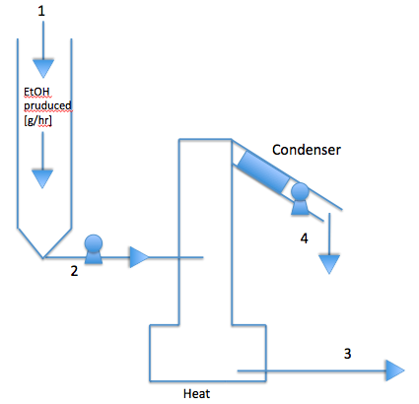
Figure 5. Schematic of the system using distillation only

In order to find the energy required to produce a gram of ethanol and the percent recovered, flow rates in the model must first be calculated. This flow rate is calculated based on the flow rates of ethanol, water, and total flow rate in g/hr at each point, which are referred to as E, W, and F respectively. It is based on the assumption that the weight percent of ethanol is 95% in the distillate and 0.25% in the bottoms stream. Also, it is assumed that the media feed stream is constant and the ethanol production rate is an input variable, which allows us to calculate the ethanol percentage based on the following equation:
$${EtOH\%}_{2}={E_{2}}/{F_{2}}$$
The ethanol flow rates at points 2 and 3 can also be expressed in the following equations:
$E_{3}=F_{3}*{EtOH\%}_{3}$ (1)
$E_{4}=F_{4}*{EtOH\%}_{4}$ (2)
The distillate flow rate can be calculated by solving a system of two equations. The first equation comes from the fact the total flow rates are conserved:
$F_{2}=F_{3}+F_{4}$ (3)
The second equation can be derived from conservation of the ethanol flow rates.
$E_{2}=E_{3}+E_{4}$ (4)
By substituting equations 1 and 2 into equation 4, the following equation is derived:
$E_{2}=F_{3}*{EtOH\%}_{3}+$ $F_{4}*{EtOH\%}_{4}$ (5)
Since EtOH%₃ and EtOH%₄ are assumed to be constant and E₂, and F₂ are input variables, equations 3 and 5 can be solved for the total flow rates and ethanol flow rates at point 3 and 4 can be solved. Assuming that the media flow rate stays constant, the initial ethanol production rate can be changed to give different initial ethanol concentrations. The affect of initial ethanol concentration of the distillate and bottom stream flow rates can also be observed.

3.4 Hybrid Pervaporation-Distillation Model
In the second model, the initial ethanol stream leaving the fermenter is concentrated via an organophillic pervaporation module. The permeate is then fed into the same distillation column as in the first model and distilled to 95 wt% ethanol. Figure 6 below shows the general schematic of the hybrid pervaporation-distillation model. Media is fed into the reactor at point 1, where ethanol is produced at a rate in g/hr and a water-ethanol effluent stream leaves at point 2. The fermenter effluent then is pumped to the pervaporation module through a cell filter, since cells could potentially foul the pervaporation membrane. To achieve a high enough ethanol flow rate through the membrane, the mixture must be recycled through a pervaporation loop where the retentate is recycled back to the pervaporation loop. The flow rates within the loop at points 3, 4, and 5 are high enough to create turbulent flow within the pervaporation module so that sufficient separation can be achieved. Ethanol and water flow through the pervaporation membrane at point 10, which increases the weight percentage of ethanol in the mixture. To keep the concentration of ethanol within the loop high enough, a waste stream is pumped out of the pervaporation loop at point 6. From here, some of the ethanol is pumped back into the reactor at point 8 to decrease the amount of ethanol that is lost in the waste stream. It is assumed that the addition of more ethanol to the reactor creates a feedback loop where the amount produced will decrease proportionally so that the ethanol in the fermenter effluent stays constant. Additionally, the ethanol-water mixture pumped back into the reactor will have some of the retained minerals, which means that a smaller amount of minerals will have to be added to the reactor. The other part of the pervaporation waste stream at point 6 then goes into waste at point 7. The concentrated ethanol-water mixture then goes into the distillation column where it is distilled to 95 wt% ethanol. Similarly to the model with distillation only, a bottom stream at point 11 leaves the distillation column with a ethanol concentration of 0.25 wt% to keep the weight percentage of ethanol within the still high enough. This distillation waste stream is combined with the flow at point 7 to generate the waste stream at point 9.. The final distillate leaves the still at the top and is condensed at point 12 and pumped out of the system. This model was developed for systems with ethanol production rates less than 15 g/h.
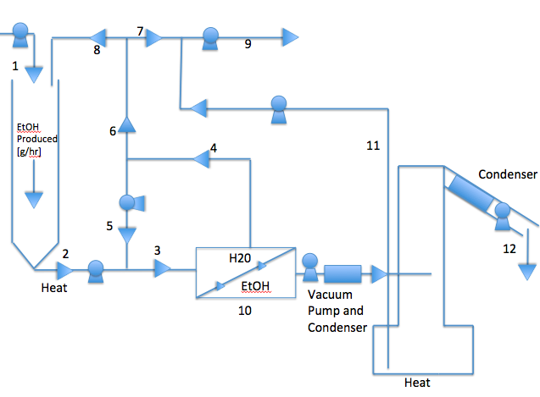
Figure 6. Schematic of the hybrid pervaporation-distillation system

The pervaporation membrane used in the model was based on information provided from Pervatech BV, a pervaporation technology company, for the PV-SR1 module. They provided the membrane type and model that would be the best to use for low concentration ethanol streams on the pilot scale. The module uses a PDMS membrane with active area of 0.1 m² that has a selectivity factor of 6 for alcohols such as ethanol [11]. The flux of ethanol across the membrane depends on the ethanol concentration in the feed stream as shown in figure 8. However, based on the area of the membrane selected, the amount of ethanol produced is less than the maximum ethanol flux across the membrane. The flux of water though does not depend on the feed concentration and is constant as seen in figure 8 below. The module has a spiral-wound design, which means that it has a high surface area to volume ratio and is better to use for concentrating alcohols than flat-plate modules. The data sheet for the module also specifies that the feed stream should go through the membrane at 0.3 m³/hr and 65°C for the best separation results.

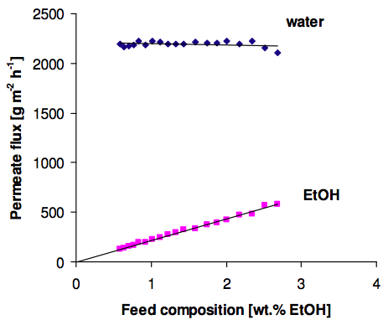
Figure 8. Flux across the PV-SR1 membrane for water and ethanol at 65°C [11]

To find the energy required per gram of ethanol recovered and the ethanol recovered, the flow rates in this model must also be found. The nomenclature used in the first model was used here as well, where F_{i}, E_{i}, and W_{i} represent the total, ethanol, and water flow rates at point i. The total flow rates at points 1, 2, 3, 6, 12, and the water flow rate at point 10 were calculated and the rest of the flow rates were calculated by the relationships shown in figure 9 below. F₁ is assumed to be constant at 40 g/hr and again the ethanol production rate is an input variable. Previous research from syngas fermentation showed that 1.2 g/hr production of ethanol is equivalent to a 2 wt% effluent stream from the fermenter, which equals a total flow rate of 60 g/hr. Based on this information, the W₂ was found to be 58.8 g/hr. Therefore, the total flow rate at point 2 is the water flow rate plus the ethanol production rate, which is a variable. F₃ was found via the PDMS membrane data sheet and calculated by multiplying the liquid flow rate times the density of the mixture at that point. Another assumption in this model is that the weight percent of ethanol in the pervaporation waste stream at point 6 is half of the initial ethanol weight percent. Using the total flow rates at points 1 and 8, the water flow through the membrane, and the ethanol weight percent at point 6, F₆ can be calculated using the following equation:
$F_{6}={(F_{1}+F_{8}-W_{10})}/{(1-{EtOH\%}_{6})}$ (6)
W₁₀ was found by multiplying the water flux from figure 8 by the area of the membrane, which was assumed to be 0.1 m² . The flow rate of distillate was calculated in the same way that it was for the first model by assuming that the distillate is 95 wt% ethanol and the bottom stream is 0.25 wt% ethanol. Since the feed stream flow rate and weight percent are known, the following equations can derived:
$F_{10}=F_{11}+F_{12}$ (7)
$E_{10}=F_{11}*{EtOH\%}_{11}+F_{12}*{EtOH\%}_{12}$ (8)
These equations can be solved simultaneously for F₁₁ and F₁₂. Additionally, at any point in the model the ethanol flow rate can be found by multiplying the total flow rate times the ethanol weight percent.

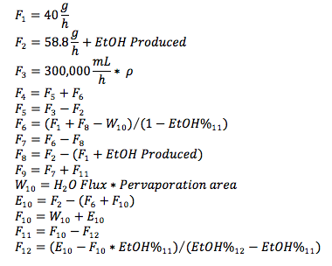
Figure 9. Flow rates for each point in the model for the hybrid pervaporation-distillation system.
The input variables are media flow rate, ethanol produced, pervaporation area, and ethanol weight percentage at point 6.

3.5 Energy Calculations
An energetic comparison was made between the two systems by finding the amount of energy required per gram of ethanol recovered. In calculating the energy for each part of the systems, 100% efficiency was assumed for both models. For the first system, the energy required was equal to the energy for the distillation of the effluent from the fermenter. The energy required to continuously distill the feed stream was calculated based on the energy it takes to increase the temperature to the distillation temperature, the energy it takes for vaporization, and the energy for condensation of the distillate stream. The following equation was used to calculate the amount of energy required to raise the temperature of the feed in the distillation column to the temperature that the mixture is to be distilled at:
$Q=\dot{m}*C_{p}*∆T$ (9)
In this equation, $\dot{m}$is the mass flow rate of the feed coming into the distillation column in g/hr, $C_{p}$ is the specific heat of the feed in J/g*K, and $∆T$ is the difference in feed temperature and distillation temperature in K. The specific heat of ethanol and of water are both known constant values, therefore the specific heat of the mixture can be calculated by finding a weighted average between the two based on the weight percent of the feed. The temperature of the effluent leaving the fermenter was assumed to be 35°C and the distillation temperature of the mixture was found by referencing a table in the CRC Handbook of Chemistry that has the boiling point of a ethanol-water mixture based on the ethanol weight percentage.

To calculate the energy required for the phase change from liquid to vapor for the ethanol-water mixture, the following equation was utilized:
$Q=\dot{m}*∆H_{v}$ (10)
As in equation 9, $\dot{m}$ is the mass flow rate of the feed stream in g/hr. $∆H_{v}$ is the heat of vaporization of the mixture in KJ/g. This constant was calculated by finding the weighted average between the heat of vaporization of ethanol and that of water based on the ethanol weight percent of the feed. Finally, the heat required for condensation is considered. This was calculated using equation 10 where $\dot{m}$ the mass flow rate of the distillate and $∆H_{v}$ is the heat of vaporization of the distillate. The energy required per gram of ethanol recovered was then calculated by dividing the amount of energy per hour by the grams of ethanol recovered per hour.

Similarly, the total amount of energy required for the second system was found by adding the energy for pervaporation and distillation. The energy for distillation was found by using equations 9 and 10 as described above. The energy for pervaporation, however, was calculated by adding the energy to heat the liquid at point 2, the energy required for the pump and condenser, and the energy required for the vacuum pump. The energy required to heat the effluent from the fermenter was calculated using equation 9 where the mass flow rate was equal to the flow rate at point 2 where the liquid is heated. The initial temperature of the ethanol-water mixture was again assumed to be 35°C and the pervaporation feed stream was heated to 65°C. The energy for the recycling pump was estimated based on the power rating of a pump found at Flowrox that could provide the necessary flow rate of 300,000 ml/hr and was calculated to be 720 KJ/hr [12]. This pump is assumed to be used for a small scale system with ethanol production rates less than 15 g/h and is constantly run during this process. Finally, the energy for pervaporation was found by assuming that the energy used by the pump was equal to the energy required to vaporize both the water and ethanol transported through the membrane. This energy was calculated using equation 10 and the flow rates of ethanol and water at point 10 in the pervaporation-distillation model. Energy required to condense the permeate was calculated using equation 10 and was considered to be part of the pervaporation energy.

4. Results and Discussion
The energy required per gram of ethanol recovered was compared for both systems for initial ethanol concentrations from 0.5 to 15 wt% and is presented in table 1. A scatterplot was then made for the energy required per gram of ethanol vs initial ethanol weight percent as shown in figure 9 with trend lines added.

Table 1. Energy required per gram of ethanol required for 0.5 to 15wt% ethanol in the initial feed stream.
Ethanol in Feed Stream (g/h) | Ethanol Cocentration (wt%) | Pervaporation/Distillation System (KJ/g) | Distillation System (KJ/g)
0.30 | 0.5 | 5489.55 | 973.26
0.60 | 1 | 2319.99 | 329.00
1.20 | 2 | 1075.85 | 145.15
1.82 | 3 | 691.79 | 90.58
2.45 | 4 | 507.40 | 66.33
3.10 | 5 | 397.81 | 52.16
3.75 | 6 | 326.79 | 43.77
5.11 | 8 | 238.20 | 31.82
6.53 | 10 | 185.44 | 25.17
10.38 | 15 | 115.68 | 16.43
Figure 9. Energy required per gram of ethanol recovered vs initial ethanol feed concentration for both the distillation and hybrid systems

In low concentration ethanol streams less than or equal to 15 wt% ethanol in a small-scale system, the hybrid pervaporation-distillation system will never be energy efficient. The reason for this is that the high-speed pump for the pervaporation loop accounts for more than 80% of the energy use in small scale systems such as this where ethanol production rates are less than 15 g/h. However, at a larger scale with a bioreactor that could produce significantly higher amounts of ethanol, the energy required for the pump will not be as significant as it is in this system. This is visualized in figure 10 below by comparing the percent of total energy used in the hybrid system by each part of the system for a 2 wt% initial feed stream. In an effort to decrease the energy required for the hybrid system, a heat exchanger was added before the pervaporation loop. This heat exchanger would use the heat at point 6 to heat the fermenter effluent at point 2, thus decreasing the energy required to heat the mixture before the pervaporation loop. The heat exchanger was assumed to have an efficiency of 0.8, meaning that 80% of the maximum theoretical heat that could be transferred from point 6 to point 2 will used to heat point 2. Results from this were omitted since the energy saved was still negligible compared to the energy required for the high-speed pump.

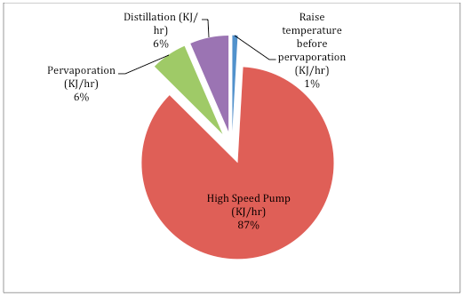
Figure 10. Percent of total energy used in the hybrid system by each part of the system with a 2 wt% initial feed stream, specifically for a small scale system

An important trend to notice in figure 8 is that the difference in energy consumption is largest when the initial ethanol production rate is the lowest. The energy difference decreases as the initial feed production rate increases because pervaporation will have more of an effect on energy savings. Pervaporation is the most inefficient at the lowest ethanol concentration since the mixture will be almost all water at this point and there will not be a significant increase in ethanol concentration. As the weight percent of ethanol in the fermenter effluent increases, the factor by which the pervaporation module will enrich the mixture by will also increase. This increased effect of the pervaporation module translates into significant energy savings in the distillation.

The model was also run without considering energy required for the high-speed pump for comparison’s sake. If the fermenter production rate were several orders of magnitude higher, the relative energy requirement for the high-speed pump would be much less than that of the pervaporation and distillation processes in the system. Therefore, running the model with this condition provides for an analysis of a larger scale system. Figure 11 shows the energy per gram of ethanol recovered for the same range of initial ethanol concentrations for both systems under this assumption. Under these conditions, the hybrid pervaporation-distillation system is less energy intensive for feed streams below 2 wt% ethanol and is only slightly higher than distillation for all concentrations greater than 2 wt%. According to these results, energy savings are marginal to nonexistent using currently available membranes and the hybrid system cannot be energy efficient. Figure 12 below shows this same data represented as the percent of the combustion energy of ethanol, which is 29.7 KJ/g. The values for this data are also shown in table 2. The trends of the graph are the same as in figure 11, as it is based on the same data. However, based on this model, the energy required to recover a gram of ethanol will be greater than the combustion energy of ethanol for both systems until the feed stream reaches initial feed concentrations of 10 wt% ethanol or greater. One reason why the energy values for distillation are higher than what is seen industrially is because the ethanol flow rates in this system are very low. The maximum ethanol flow rate in this system is 10.4 g/h when the feed stream is 15 wt% ethanol, which is several magnitudes lower than typical ethanol flow rates industrially.

Figure 11. Energy required per gram of ethanol recovered vs initial ethanol feed concentration for a hybrid pervaporation-distillation system without a high-speed pump compared to the distillation system

Percent Ethanol (w/w %) | Pervaporation/Distillation System (%) | Distillation System (%)
0.5 | 2372.2 | 3266.0
1 | 1006.9 | 1105.6
2 | 471.0 | 479.2
3 | 305.6 | 304.0
4 | 226.2 | 222.6
5 | 178.9 | 175.0
6 | 148.5 | 144.6
8 | 110.2 | 106.8
10 | 87.5 | 84.5
15 | 57.4 | 55.1

Table 2. Energy consumed as a percent of the combustion energy of ethanol (%)

Figure 12. Energy consumed for both the hybrid and distillation systems as a percentage of the combustion energy of ethanol, which is 29.7 KJ/g

Finally, the percent ethanol lost in both systems compared to the initial amount produced in the effluent is shown in figure 13 below. At ethanol concentrations of 0.5 wt% and below, there is more ethanol loss in the distillation system. However, as the initial ethanol concentration increases, the amount lost in the distillation system decreases exponentially and reaches 1.5% loss at a feed concentration of 15 wt% ethanol. For the hybrid pervaporation-distillation system, the percent lost decreases much less rapidly as the initial feed concentration increases. This is because there are waste streams for both the pervaporation loop and for the distillation column, which means that the amount lost will always be greater for the hybrid system than for the distillation system, even though some of the ethanol is being recycled back to the fermenter.

Figure 13. Percent ethanol lost for both the distillation system and hybrid pervaporation-distillation system from 0.5 to 15 wt% ethanol in the feed

5. Outlook
Based on this model, a hybrid pervaporation-distillation system will require significantly more energy to recover 95 wt% ethanol from low concentration feed streams than distillation alone for small scale systems and it would not be recommended that it be implemented. This model was run with ethanol production rates less than 15 g/h, so the rate of ethanol recovered was very low. Even if the system were operated on a much larger scale so the energy for the high-speed pump could be neglected, the energy saved would only be seen at feed concentrations less than 2 wt% ethanol. Also, the installation and maintenance costs would be too high for this to be a worthwhile system to use to concentrate ethanol. To see if the hybrid pervaporation-distillation system would ever be more energy efficient than distillation alone, the media flow rate and ethanol production rates could be scaled up to a much larger system. In a system with higher ethanol production rates, the energy consumption for the high speed pump would not be as significant since the energy required for distillation and pervaporation would be much higher. However, the pervaporation module would also need to be scaled up in order to handle the high flow rates of ethanol and water through the membrane. Modeling an industrial scale system and comparing it to a small-scale system would allow for a better evaluation of a hybrid pervaporation-distillation system such as this. With effluent flow rates greater than 300 L/h, a hybrid pervaporation-distillation system could be more energy efficient.

The reasoning behind implementing pervaporation before distillation was that energy would be saved by not having to evaporate as much water in the distillation step. If the feed stream could be concentrated high enough, the specific heat and heat of vaporization would both be lowered significantly and the energy required for distillation would be much less. Currently, hydrophobic membranes available do not have separation factors exceeding 15, but hydrophilic membranes have been developed with separation factors above 50 even. If organophilic membranes were developed with much higher separation factors, the distillate feed stream would be much more concentrated, which would make this system energy efficient. Further research can be done using similar modeling to find the membrane separation factor at which the system could become energy efficient. Overall, pervaporation has the potential to be an energy saving alternative to distillation on the small scale, but current restrictions on membrane performance do not make it a viable process to be implemented to concentrate ethanol.

References

1. Field, R. W. and Lobo, V. (2003), Hydrophobic Pervaporation. Annals of the New York Academy of Sciences, 984, 401–410.
2. Ornthida S, Somenath M. Pervaporation in chemical analysis. Journal of Chromatography A, Volume 1217, Issue 16, 16 April 2010, Pages 2736–2746
3. Xu, Weihua. (2001). Design and Development of a Pervaporation and Separation Module. National Library of Canada.
4. Shao, P. and Huang, R. (2006). Polymeric Membrane Pervaporation. Journal of Membrane Sciences, 287, 162-179.
5. Cheng-Ching, Y and Ward, J. Analysis of Local Recycle for Membrane Pervaporation Systems. (2012). Industrial & Engineering Chemistry Research 51 (29), 9790-9802.
6. Kujawski, W. (2000). Application of Pervaporation and Vapor Permeation in Environmental Protection. Polish Journal of Environmental Studies, 9 (1), 13- 26.
7. Wang, Y. et al. (2010). Separation of ethanol/water azeotrope using compound starch-based adsorbents. Bioresource Technology, 101 (15), 6170-6.
8. Enweremadu, C. Energy Conservation in Ethanol-Water Distillation Column with Vapor Recompression Heat Pump. University of South Africa, Florida Campus.
9. Vane, L. and Alvarez, F. (2008). Membrane-assisted vapor stripping: energy efficient hybrid distillation–vapor permeation process for alcohol–water separation. Journal of Chemical Technology and Biotechnology, 83, 1275-1287.
10. Katzen, R. et al. Ethanol distillation: the fundamentals. Katzen International Inc, Cincinnati, OH.
11. Data sheet PDMS pervaporation membrane. Pervatech BV. 2013
12. LPP-T25 Hose Pump Technical Data Sheet. Flowrox. 2013. <http://www.flowrox.com/tiedostot/LPP-T/Flowrox/LPP- T25/Flowrox_LPP-T25-technical-datasheet_ENG.pdf>
13. Vane, L. (2005). A review of pervaporation for product recovery from biomass fermentation processes. Journal of Chemical Technology and Biotechnology, 80, 603-629.

