Masters of Engineering Report:
West King Road Stormwater Rehabilitation Project

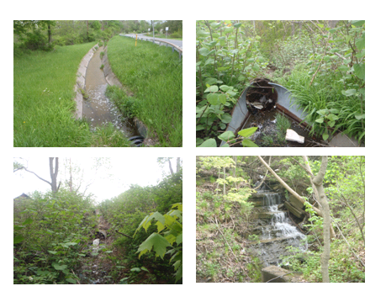

(Location: West King Rd., Ithaca, NY 5 May 2011)

Report submitted on 3 August 2012 to:
Todd Walter
200 Riley Robb
Ithaca, NY 14853

Report Submitted by:
Johnathan Licitra
102 Armstrong Rd.
Lansing, NY 14882

Table of Contents:
Cover Page 1
Table of Contents 2
Abstract 3
Background & Scope 3
Location / Watershed Characteristics 3
Tasks 7
Results 7
Outlet Structure Reinforcements 10
Solution #1: Weir & Armored Channel 13
Solution #2: Catchbasins & Piped 17
Solution #3: Catchbasin & Armored Channel 20
Cost Comparison of Solutions 20
Conclusions / Recommendations 22
Appendix 1: Watershed Calculations 23
2: Existing Watershed Structures 28
3: Solution#1 34
4: Solution#2 37
5: Solution#3 38

Abstract:
The Town of Ithaca’s Public Works Department mission is to maintain the road infrastructure for commerce throughout the town. Part of this maintenance includes providing proper conveyance of stormwater—one such area that needs rehabilitation is along the intersection of West King Rd and Stone Quarry Rd in Ithaca, NY. This report discusses the background, hydrology, and 3 potential engineering solutions for the current erosion problem. After engineering capacity calculations and a material cost comparison, a weir and armored channel approach is recommended.
Background & Scope:
The Town of Ithaca Public Works Department plans to redesign a section of failing stormwater drainage system along West King Road. This drainage channel rehabilitation is needed to protect the road from undermining and the adjoining property owner’s land. What makes this project unique are some of the specific parameters of the area: steep road bank, concrete lined channel, and an outlet into a gorge. Due to budget constraints only the energy dissipation and outlet sections of the drainage system are scheduled for construction work in 2012.
For this design project, I intend to survey and design multiple approaches to solve the current West King Road stormwater conveyance problem. Understanding the characteristics of this watershed are the first steps towards determining which rehabilitation designs to implement. Specific watershed engineering characteristics (i.e. time of concentration, runoff volume, peak flows) are necessary to properly plan for system design considerations. The Town of Ithaca needs to understand the current and future watershed stormwater runoff characteristics for a 25 and 100 year storm.
Therefore, this project’s scope is to determine the watershed’s stormwater characteristics (i.e. watershed land use map, peak runoff rate), and design alternative energy dissipation structures to address the current problem of a failing stormwater conveyance system.

Location / Watershed Characteristics:
The area of concern is located near the intersection of West King Road and Stone Quarry Road in Ithaca, Tompkins County, New York. A nearby landmark for the area is east of Upper Buttermilk Falls State Park and southwest of Ithaca College. The watershed area is 101.9 acres with an average slope of 4.8% and 379 feet of relief change (Appendix 1).
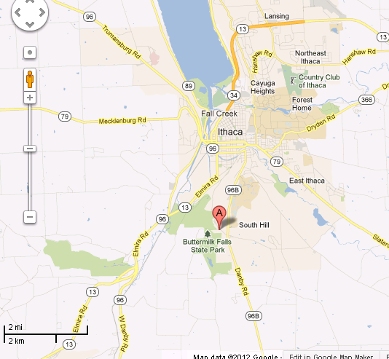
Figure 1. The “A” represents the location of the outfall and concrete lined channel (Google Maps, 2012).
The Town of Ithaca is responsible for the road maintenance of West King Road which includes: paving, plowing, road signs, and road drainage. Prior road work repairs to this section of road during the last 50 years include: partial concrete lining of an open channel turning into a piped channel, which then outlets into a 3’ culvert which then turned into a mix of concrete rubble and rip-rap lined channel before entering a gorge (Appendix 2 includes a detail of each stormwater structure). The current problem is that the 3’ culvert is failing to convey the stormwater adequately because it is separated into 5 pieces and the runoff has greatly eroded its banks. Figure 2 depicts the major problem.
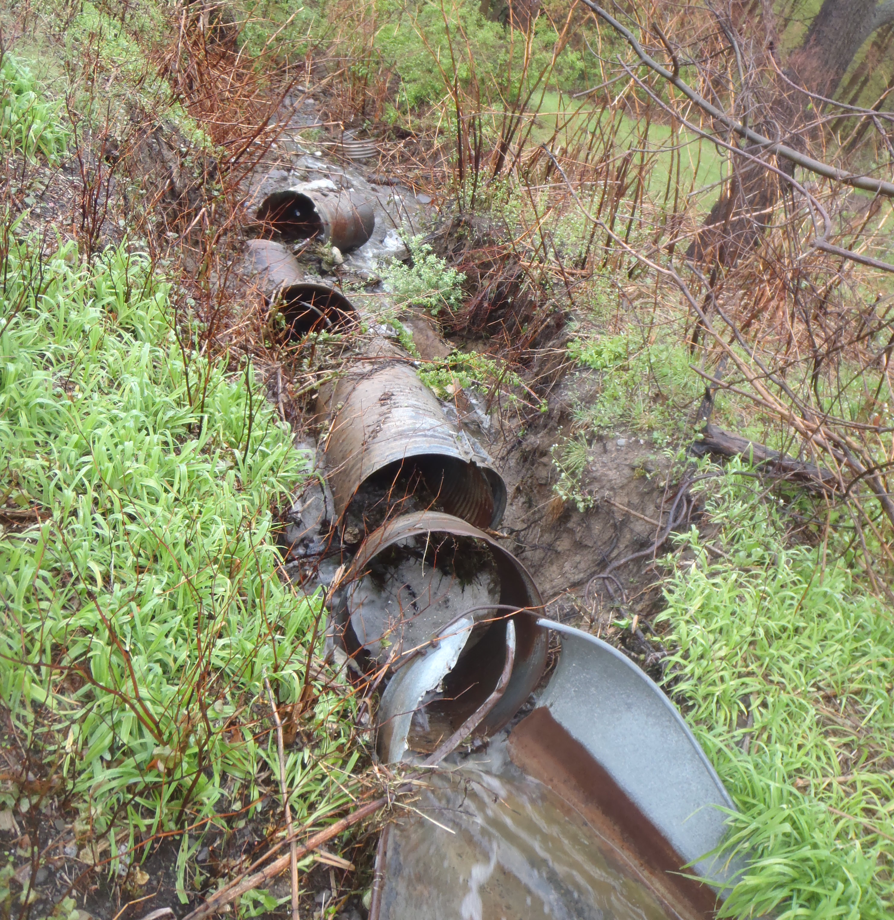
Figure 2. Picture of failing 3’ culvert at the outlet of the watershed (taken 4 May 2012).
For this watershed, a majority of the soils are classified as class C hydrologic group. The USDA NRCS Web Soil Survey provides the soil classification.
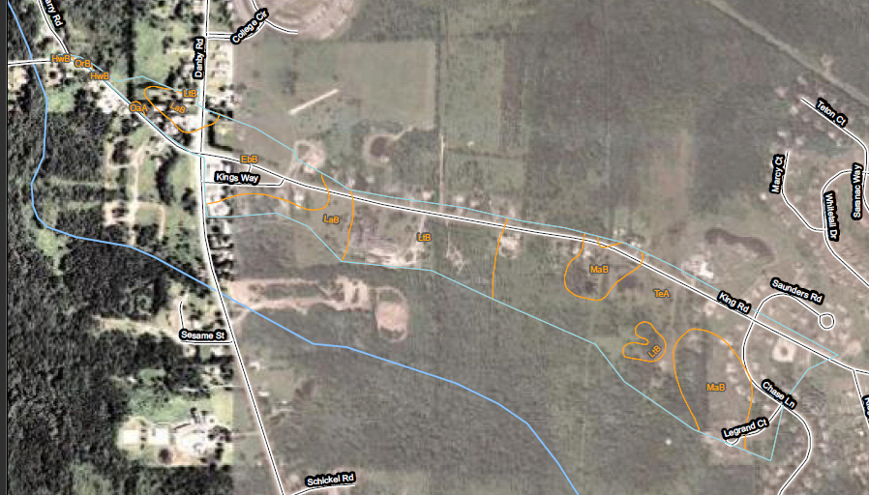
Figure 3. Soil map survey information of the watershed.
Table 1. Soil names and descriptions for the watershed.
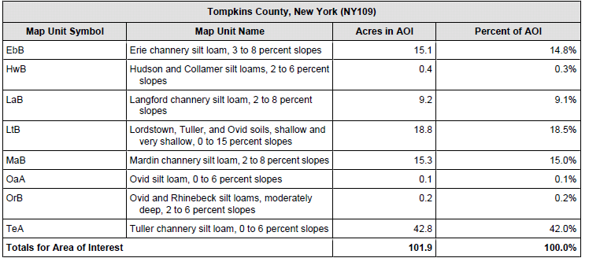
Land use in the area is predominantly a mixture of woods, grass, residential, and paved. Land use classification is assessed using ESRI Geographic Information System (GIS) software and data provided by Tompkins County GIS Department 2007. Additional impervious roads classification was performed via heads-up digitization process. 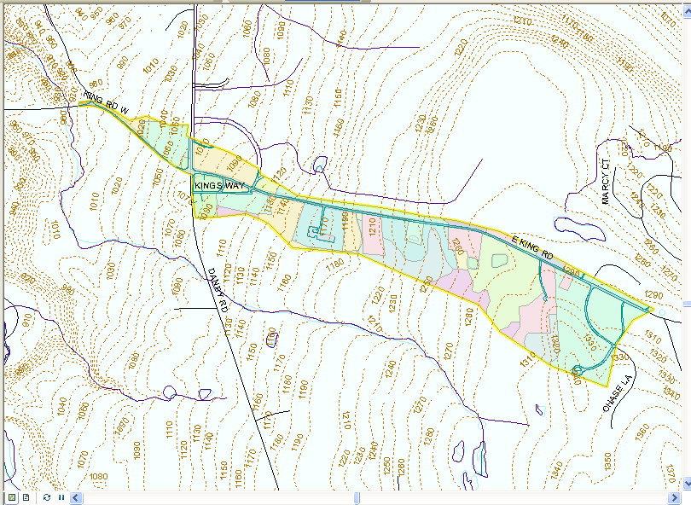
Figure 4. Map displays the non-generalized land use classification for the watershed.
Tasks / Methods:
Design Storm: This project intends to compare the existing capacity of the current stormwater infrastructure and a proposed design to handle the 100 year 24 hour storm. Although NYSDOT standards typically design for a 25 year storm, this area is so unique and steep the Town intends to plan for the 100 year storm. USDA NRCS provided the Type II rainfall distribution data for the 24 hour storm in Tompkins County, NY. Total flow depths, volumes, d peak flows were calculated in Appendix 1 for the overall watershed. Table 2 provides a summary of the flow data.

Table 2. Summary of the design storm and flows for the overall watershed.
 | 25 yr | 100 yr
24 hr (in) | 4.6 | 5.5
Flow depth (in) | 2.72 | 3.53
Flow volume (ft^³) | 1.01* 10⁶ | 1.31* 10⁶
Peak Flow (ft^³/sec) | 454 | 588
I completed a land survey of the design area during the first week of July 2012. Land survey data collection used a Trimble RTK data receiver to establish baseline data, and then a Leica Total Station Laser with a Trimble data collector logger for the survey. Data points were processed using Microstation to begin mapping the current conditions. As of date, final plans have not been drawn-up on CAD. This land survey data will be used for all final designs and construction plans.

Results:
Using the 100 year design storm as a guide, 3 potential design solutions are proposed for this stormwater problem: 1) Weir and Armored Channel, 2) Catchbasin & piped, 3) Catchbasin & armored channel. For each potential solution, basic design principles and cost estimates are discussed below.
Basic design approach assumptions include: using the existing concrete lined-channel as the maximum flow rate (100 CFS) and velocity (11.8 Ft/sec) for the calculations to match for the design areas (See Appendix 3 for calculations). The location of the beginning of the design is called J under Appendix 2. Figure 5 maps the design area in relation to West King Rd and Stone Quarry Rd.
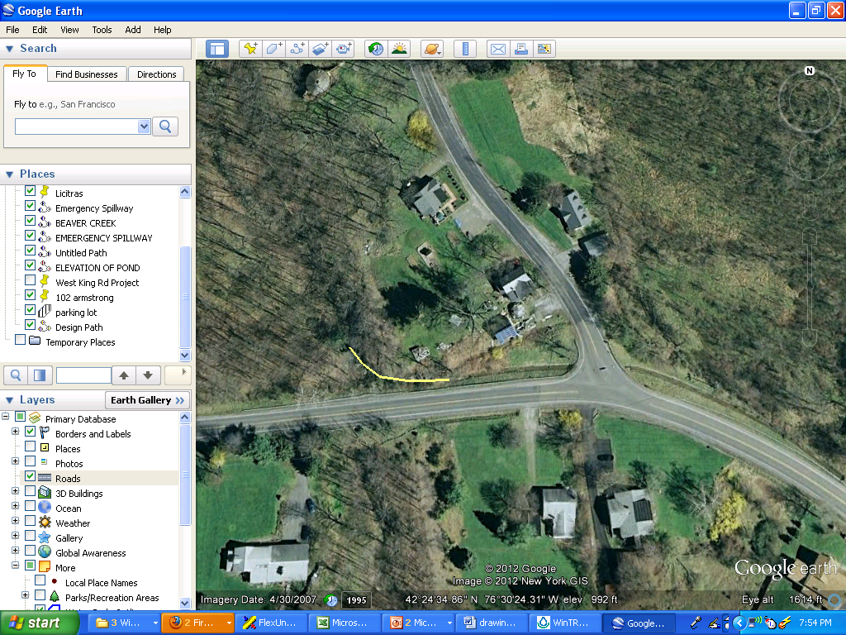
Figure 5. The yellow area displays the design area (Google Earth 2012).
The design area is 140’ in length, average slope of 23.5, and a 33’ change in relief. The inlet side of the design area receives stormwater from the concrete lined-channel and the outlet side of the design area is a gorge. Figure 6 and Figure 7 display the plan and profile views of the design area from the land survey. The inlet side is severely eroded along the banks of the channel and the middle section around stationing 100 has existing concrete rubble and rip rap and the last 40’ is in rock.
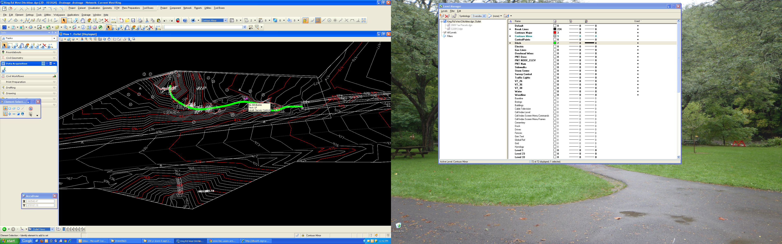
Figure 6. Plan view of the design area highlighted in green.

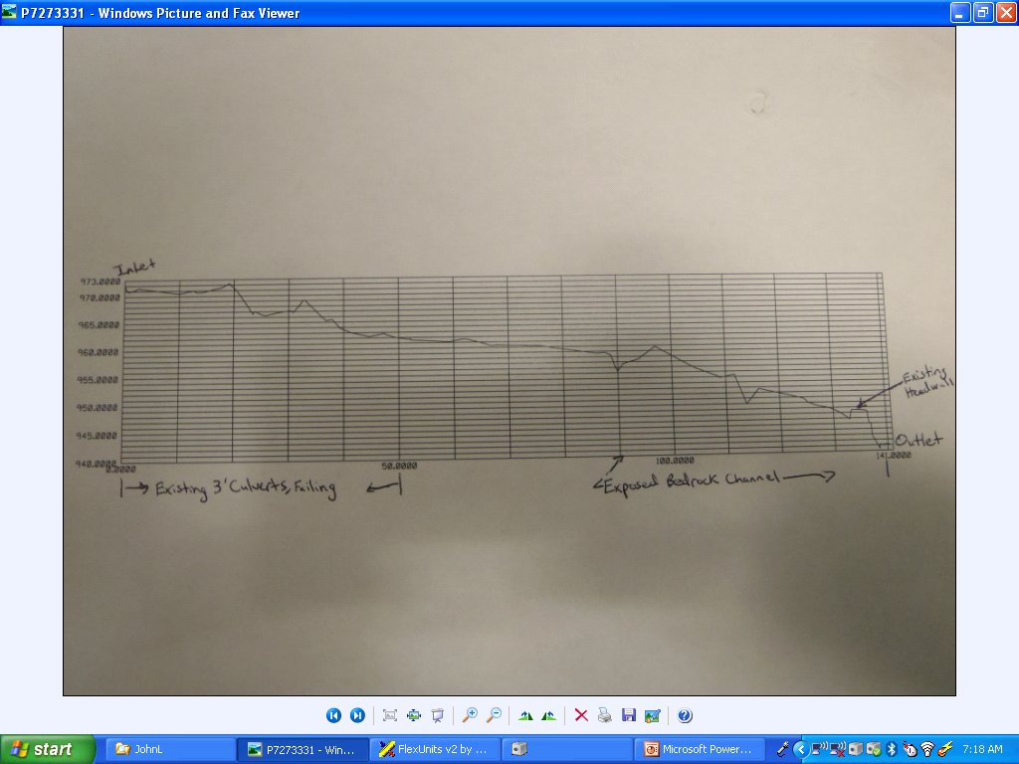
Figure 7. Current profile of the design area.
Some additional existing conditions observations were: a 5’ box culvert is 5’ before the outlet, the box culvert is currently in the hydraulic grade line of the channel which is causing the wingwall and side of the box culvert to be undermined, the keystone and headwall of the box culvert are cracked.

Outlet Structure Reinforcements: All solutions will need to address the box culvert’s failing wingwall and headwall. Figure 8 & 9 depict the box culvert’s structural failures viewable from the surface. Future solutions will need to inspect the interior box culvert via pipe video cameras looking for interior cracks. Slip lining the box culvert would be a potential future solution for any major defects in the main chute of the box culvert.
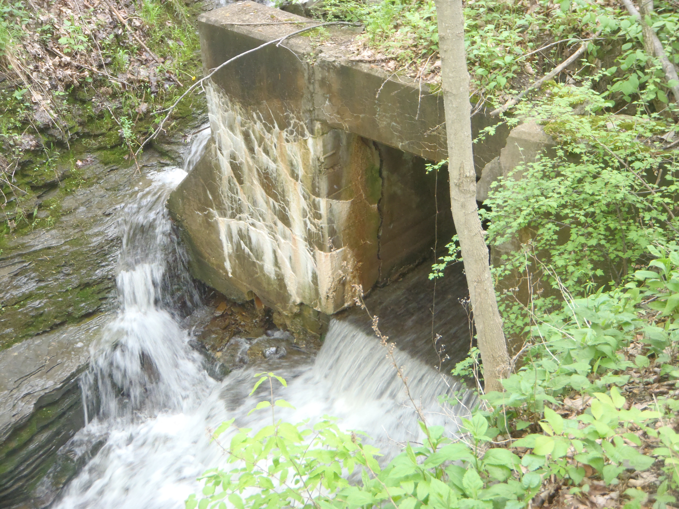
Figure 8. Existing box culvert being undermined by current design area channel.
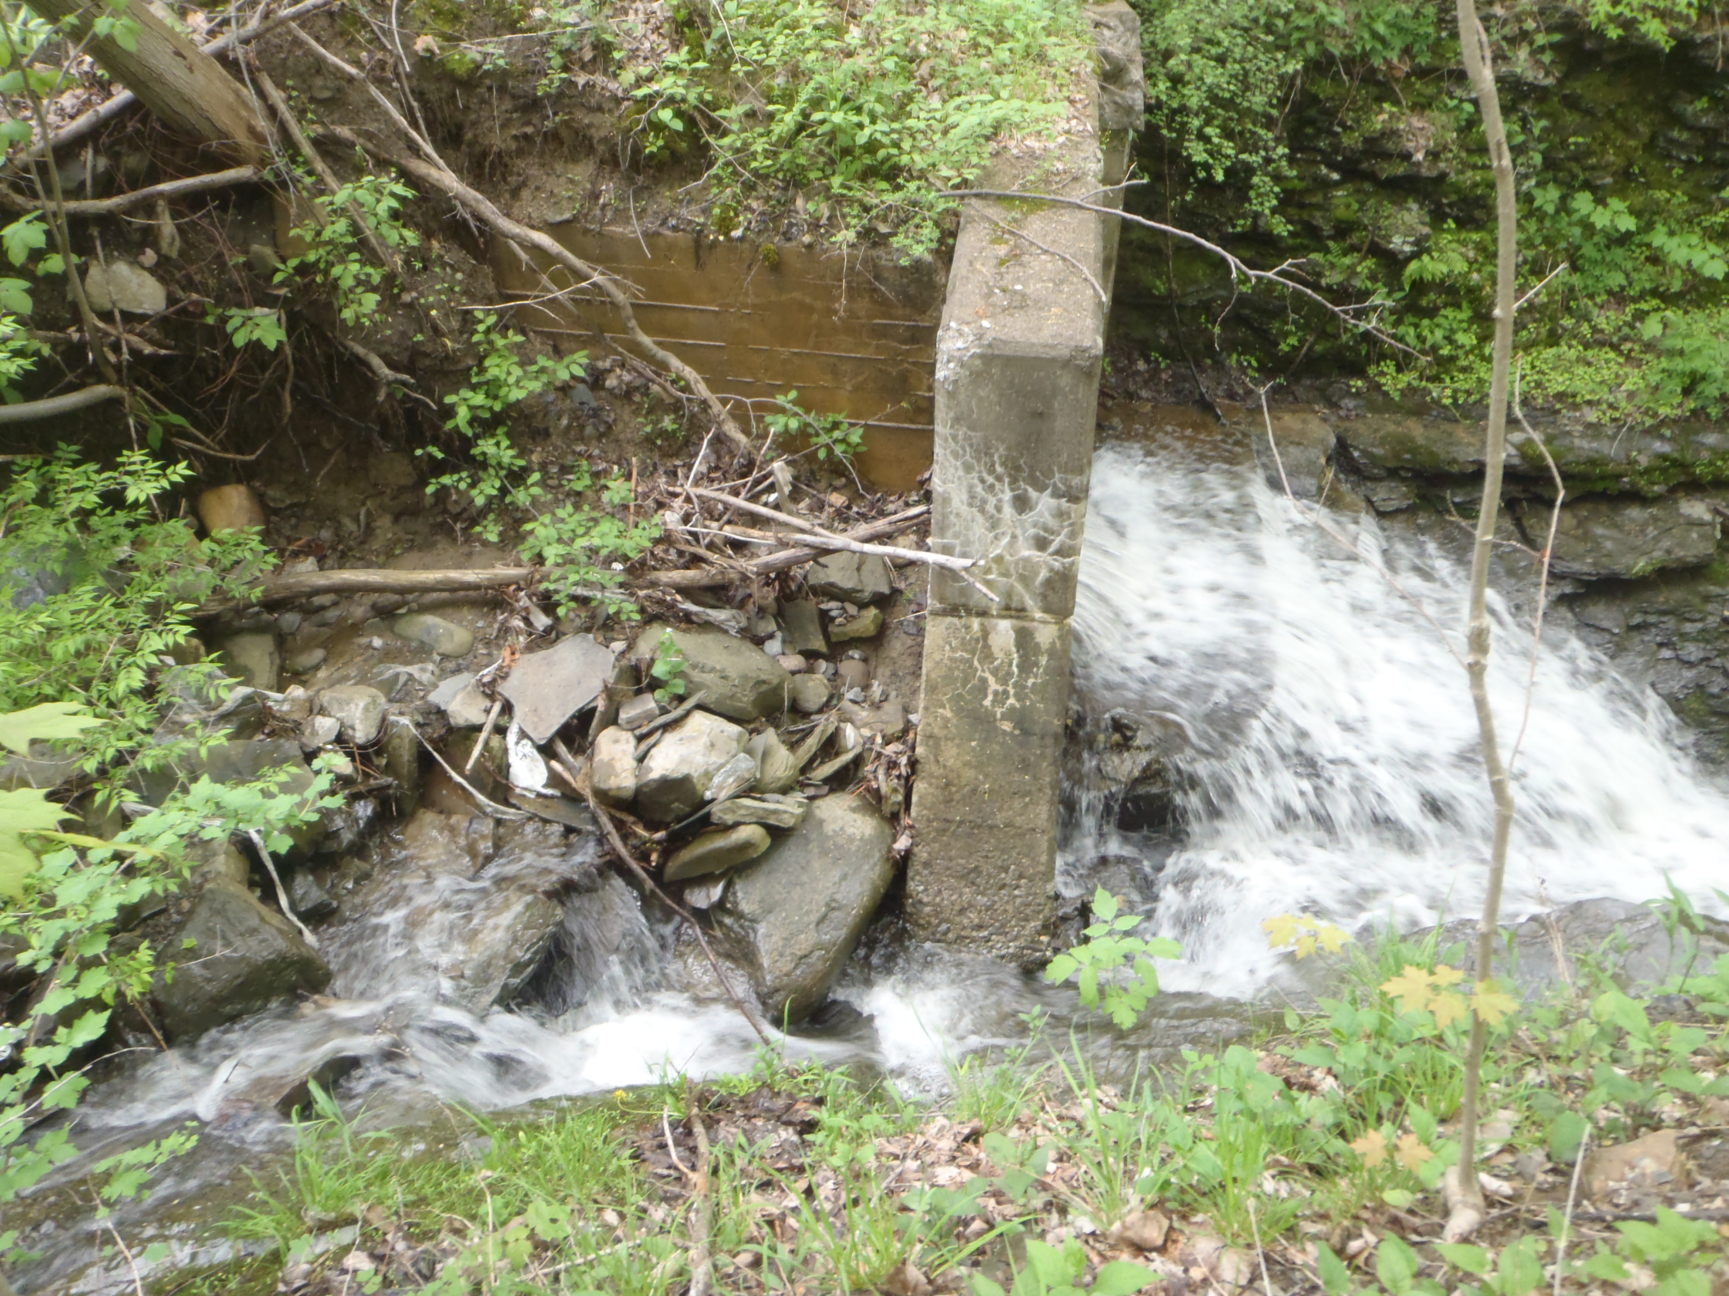
Figure 9. This displays the erosion along the sidewall of the box culvert.
This study’s solutions will include supporting the eroded side wall of the box culvert and changing the flow path past the wingwall. Concrete lego blocks (2’x 2’ x 4’),as shown in Figure 10, will be used to support the box culvert’s eroding side wall by mortaring the lego blocks to the sidewall and then backfilling them. For all open channel solutions, a flow path will need to be created to redirect the flow away from the wingwall by either building up the wingwall bank with concrete or jackhammering out bedrock (Figure 10A). Any stormwater pipe solution would include piping the flow past the wingwall, but still supporting the sides with lego blocks. Table 2A provides a summary of the relevant dimensions for the box culvert’s wingwall reinforcement dimensions.
Table 2A. Summary of Relevant Dimensions: Wingwall Reinforcements (FT)
Material | L | W | Height | Total Units | Comments
Concrete Lego Blocks | 4 | 2 | 2 | 4
Anchor Bolts (4 per block) |  |  |  | 16
Masonry Caulk |  |  |  |  | As Needed

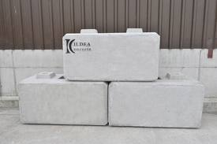
Figure 10. Concrete lego blocks will be used for the sidewall of the box culvert (Kildea.com 2012).

Current Channel  Generalization | 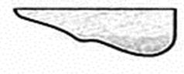
 |  |  |  |  | Wing Wall
Proposed Channel  Generalization | 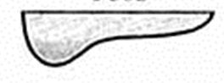
 |  |  |  |  | Lego Block & Wing Wall
Figure 10A. Cross-section of current channel and proposed channel past box culvert’s wingwall.

Solution#1Weir & Armored Channel: Approach #1 uses a weir, energy dissipation basin, and an armored channel to combat current erosion in the design area. Appendix 3 details the equations used for approach #1. The rectangular weir dimensions will be the existing concrete lined-ditch.
The energy dissipation basin is a Type 1design based upon NYS DEC Stormwater Manual and a Froude #1.74. This basin consists of a minimum tailwater length of 80’ based upon the maximum incoming flow capacity of the weir. Rip rap d50 size is equal to 24 inches or greater inside the energy dissipation basin. This select rip rap aides in stepping-down the velocity inside the eroding channel. Depending upon the exact design chosen, a select rip rap or a grouted sloping boulder drop structure may be chosen. Both of these designs are similar except for the use of grout. Figure 11 displays an example of the select rip rap, Figure 11A shows an example of a grouted sloping boulder drop, and Figure 11B shows an example of a profile for the grouted sloping boulder drop structure.
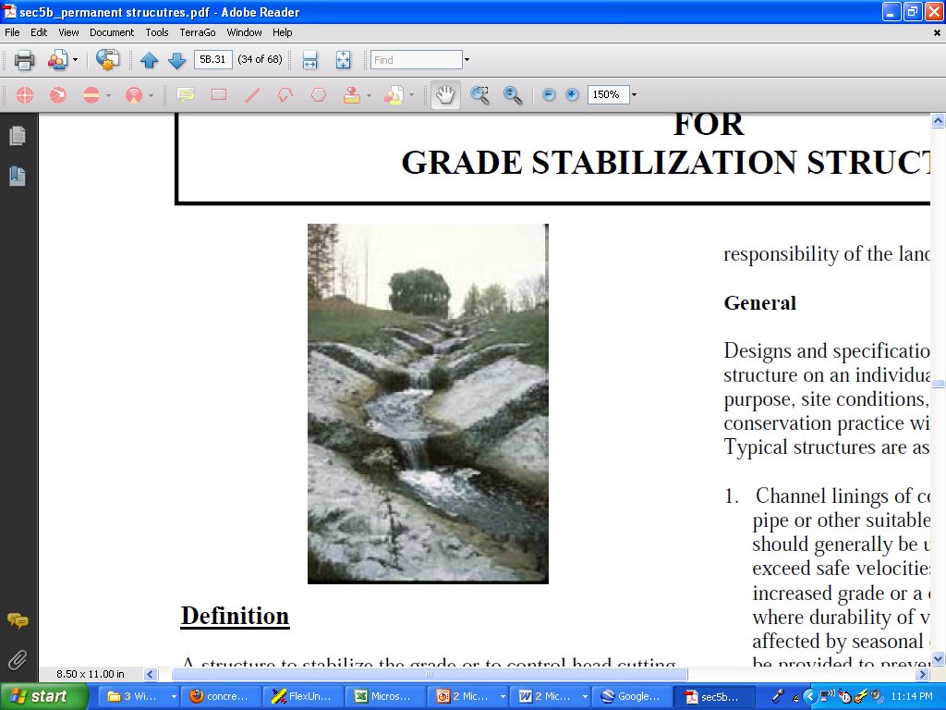
Figure 11. Typical select rip rap application.

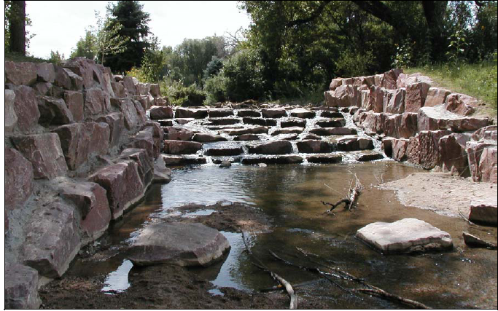
Figure 11A. Example of a grouted sloping boulder drop structure in CO. (Hunter, 2006)
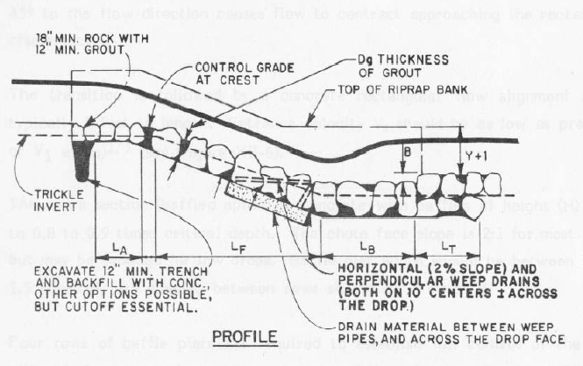
Figure 11B. Typical profile of grouted sloping boulder drop structure (Urban Storm Drainage Criteria Manual (USDCM).)
The 2:1 side slopes ratios of the channel are lined with a d50 - 18 inches or greater. Rip rap is applied at least 80’ in length and may extend longer where needed. The calculated depth of flow after the energy dissipation basin is 3.4’. Figure 11C shows an example of a sloping rip rap drop, and Figure 12 shows an example of an armored channel drawing. A summary of relevant dimensions is presented in Table 2B.
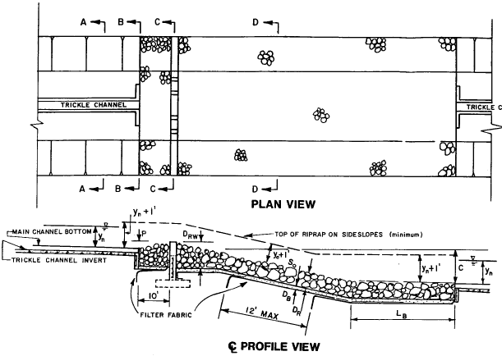
Figure 11C. Example plan and profile of a sloping rip rap drop (USDCM).
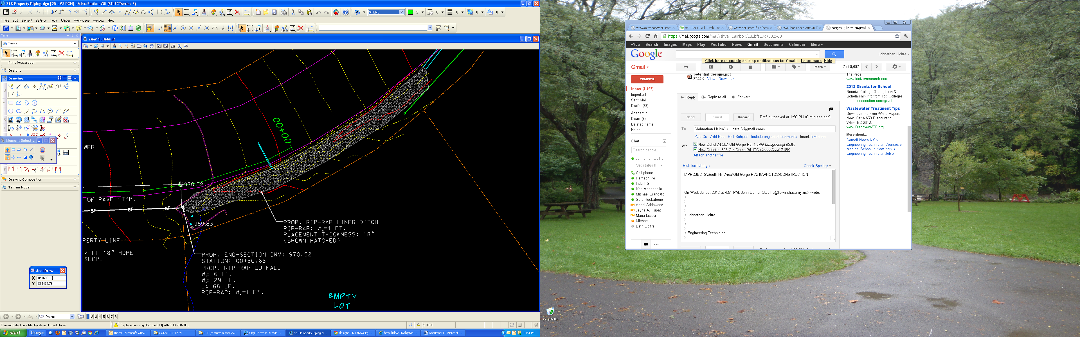
Figure 12. Displays typical armored channel plan used by Town of Ithaca Engineering.

Table 2B. Solution#1 Summary of Relevant Dimensions: Weir & Armored Channel (FT)
Material | L | W | Depth | Cubic Yards | Comments
Weir | - | 4 | 1.7 | - | Existing Concrete Channel
Main Channel 24" >= d50 Rip Rap or Boulders | 80 | 4 | 3.4 | 40.3 | Actual number of select rip rap or boulders depends upon size
Side Slope (each) 18" >= d50 Rip Rap | 80 | 3 | 2 | 17.8 | Add more as needed
Side Slope (each) 18" >= d50 Rip Rap | 80 | 3 | 2 | 17.8 | Add more as needed

Solution#2 Catchbasins & Piped Channel: Approach #2 uses a 4’ drop inlet catchbasin with a trash rack at the inlet (Figure 13). The flow then continues through a total of 120’ of 36” HDPE pipe and 3 more catchbasins. Catchbasins are located at major changes in slope and at the outlet—approximately 45’ apart. The last catchbasin design includes a short piece of 36” HDPE with a flared-end section that will dissipate into the gorge/outlet (Figure 14). Appendix 4 shows the calculations used in this potential design.
On top of the bedded and buried pipes is a rip rap channel. Since the initial 4’ diameter inlet catchbasin is rated to handle 126.8 CFS but only 10.1 Ft/sec velocity, the above rip rap channel acts as an overflow channel. If the 36” HDPE pipe surcharges because they are designed to handle 61.9 CFS and 8.76 Ft/sec, then this overflow channel can handle the extra flows. The main overflow channel is 18” d50. The overflow rip rap channel consists of 2:1 side slopes with d50 12” rip rap. Smaller rip rap is sized because this channel is now the overflow or secondary outlet for the flows. Table 2C outlines a summary of the relevant dimensions for this approach.
Table 2C. Solution#2 Summary of Relevant Dimensions: Catchbasins & Piped (FT)
Material | L | W | Depth/Height | Units | Comments
42" Catchbasin with Trash Rack | 5 | 5 | 6 | 1 | Depths are estimated
Precast Grate Inlet Catchbasin | 4 | 4 | 4 | 3 | Depths are estimated
36" HDPE Pipes | 120 | - | - | -
 |  |  |  | Cubic Yards
Rip Rap Overflow Channel on top of Pipe 18" >= d50 | 120 | 4 | 2 | 35.6
Side Slope (each) 12" >= d50 Rip Rap | 80 | 3 | 1.5 | 13.3 | Add more as needed
Side Slope (each) 12" >= d50 Rip Rap | 80 | 3 | 1.5 | 13.3 | Add more as needed

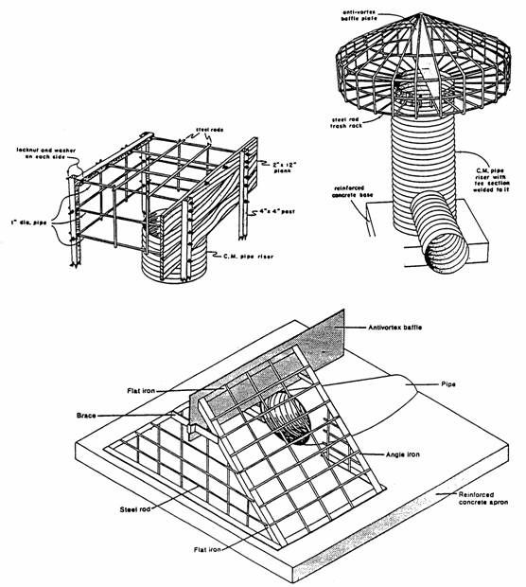
Figure 13. Examples of trash racks used by NYS DOT
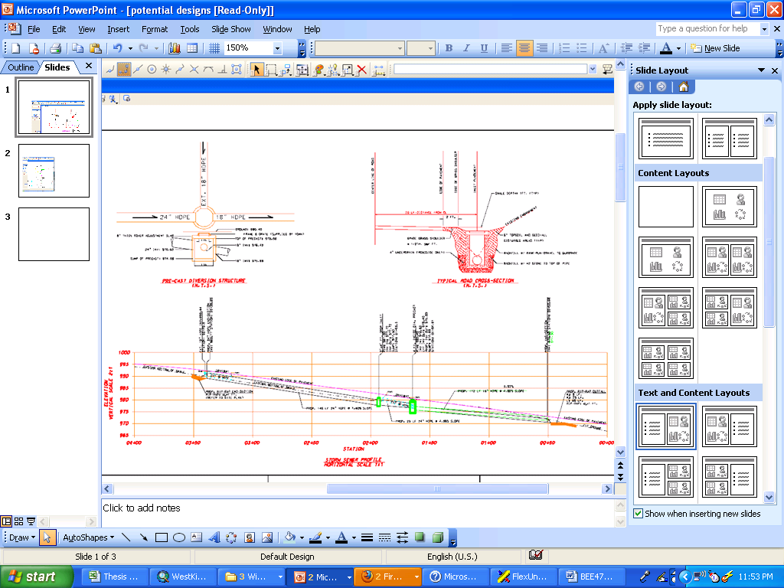
Figure 14. Displays example plan detail of catchbasins & pipes used by Town of Ithaca.

Solution#3 Catchbasin & Armored Channel: Approach #3 uses a combination of the first 2 solutions. An initial 4’ drop inlet catchbasin with a trash rack outlets into a flared-end section HDPE pipe which uses a rip-rap lined channel. This strategy uses a stabilized step select rip rap d50 >= 24” and 2:1 side slope of d50 => 18”. Appendix 3 & 4 refer to the previous calculations for the inlet catchbasin and armored rip rap channel. Table 2D shows a list of relevant dimensions for this approach.
Table 2D. Solution#3 Summary of Relevant Dimensions: Catchbasin & Armored Channel (FT)
Material | L | W | Depth | Units | Comments
42" Catchbasin with Trash Rack | 5 | 5 | 6 | 1 | Depths are estimated
 |  |  |  | Cubic Yards
Main Channel 24" >= d50 Rip Rap or Boulders | 80 | 4 | 3.4 | 40.3 | Actual number of select rip rap or boulders depends upon size
Side Slope (each) 18" >= d50 Rip Rap | 80 | 3 | 2 | 17.8 | Add more as needed
Side Slope (each) 18" >= d50 Rip Rap | 80 | 3 | 2 | 17.8 | Add more as needed

Cost Comparison of Solutions:
For each proposed design solution, an estimated total cost is computed. This total cost includes a number of constant factors for all the design solutions: Town of Ithaca labor & equipment to install the design, 4-6 man crews, less than 2 weeks for project completion, masonry caulking, site restoration, and hydroseeding. The workforce conducting the installation is experienced and has completed 2 similar drainage projects within the past year. See Appendix 5 for a breakdown of previous drainage projects.
An average cost per Linear Foot (LF) of drainage pipe installed is calculated from the 2 previous drainage projects carried out by the Town of Ithaca work crews. The average cost is $130.oo per LF of drainage. Therefore a take-off estimate for the entire drainage project cost is $18,200 based upon the 140’ design area. A material break-down of cost per design approach is found in Figure 15.
 | Weir + Stabilized channel |  |  |  |  | Catchbasin & piped |  |  |  |  | Catchbasin + Stabilized channel
Materials | Units | Unit Price | Quantity | Sub-Total |  | Units | Unit Price | Quantity | Sub-Total |  | Unit Price | Quantity | Sub-Total
Concrete Wier |  |  |  | Existing
Energy Dissipator base & fabric | SFF | 15 | 40 | 600 |  |  |  |  |  |  | 15 | 40 | 600
Rip Rap d50 >=24 | CY | 33 | 40 | 1,320 |  |  |  |  |  |  | 33 | 40 | 1,320
Side Slopes
Rip Rap d50 >=18 | CY | 30 | 36 | 1,080 |  |  | 30 | 36 | 1,080 |  | 30 | 36 | 1,080
42" Catchbasin, 6' tall, & Trash Rack |  |  |  |  |  | Each | 2,000 | 1 | 2,000 |  | 2,000 | 1 | 2,000
36" HDPE |  |  |  |  |  | LF | 31 | 120 | 3,720
Pipe Bedding Stone |  |  |  |  |  | Ton | 18 | 90 | 1,620
Precast Storm Inlet Catch Basins (2'x4') |  |  |  |  |  | Each | 600 | 3 | 1,800
Side Slopes
Rip Rap d50 >=12 |  |  |  |  |  | CY | 27 | 27 | 729
HDPE Flared End Section | Each | 300 | 0 | 0 |  |  | 300 | 1 | 300 |  | 300 | 1 | 300
Partial Material Cost Estimate = |  |  |  | $3,000 |  |  |  |  | $11,249 |  |  |  | $5,300
Figure 15. Material cost per design approach based upon 2012 Town of Ithaca price quotes.

Conclusions/Recommendations:
Based upon the unique site conditions and the 100 year design storm requirement, I recommend Solution#1—the weir and armored channel. This approach is the most economical and will require less heavy equipment to move materials when compared to the catchbasins and pipes approach. The existing channel is narrow and has steep side slopes, so construction access is an important consideration as well. Much attention to detail is required during construction to ensure a properly bedded select rip rap and side slope rip rap.
Before construction can begin, proper land easements and construction easements must be gained. Neighboring property owners have vested interest to see the success of this project, but the Town of Ithaca needs to possess easements to maintain the channel in the future. Proper, periodic cleaning of the weir and armored channel are required too. Following the DEC Stormwater Design Manual ensures success of this project.

References:
Chin, D.A. Water Resources Engineering. Prentice Hall. Upper Saddle River.
Chow, V.T. 1959. Open Channel Hydraulics. McGraw-Hill Company, New York.
Hunter, M. 2006. Drop Structure Selection, Construction, and Maintenance Part 2. White Paper for the Urban Storm Drainage Criteria Manual.
Teledyne Isco. 2006. Isco Open Channel Flow Measurement Handbook. 6th Edition. Lincoln, Nebraska.
New York State Standards and Specifications for Erosion and Sediment Control. 2005. http://www.dec.ny.gov/chemical/29066.html
New York State Stormwater Management Design Manual. 2010. http://www.dec.ny.gov/chemical/29072.html
Tompkins County GIS Department. 2007. Land Use Classification Data.
Town of Ithaca. 2012. Engineering Plan Details and Project Costs.
US Dept of Agriculture, Natural Resources Conservation Service. 2012. Web Soil Survey. Accessed May 5, 2012. http://soils.usda.gov/
US Dept of the Interior, Bureau of Reclamation. 1977. Design of Small Dams. US Government Printing Office, Washington, DC.
Appendix 1:Watershed Calculations

Watershed calculations:
This watershed was delineated by eye from a topographic map using stream channels, contour ridge lines, and field inspections as the primary guiding features. The watershed was then digitized using ESRI ArcMap software. Many of the watershed calculations were automated using the GIS software.
Watershed Area = 101.9 acres or 0.16 mi²
Average Watershed Slope with 379’ of relief = 4.8%

Time of Concentration used the Kirpich (1940) method.
t_{c} = 0.0078L^{0.77}S^{0.385}
L is the length of the longest flow path = 7937 FT
S is the overall watershed slope = 4.8 %
t_{c} is calculated to be 25 mins.

Note that the critical storm duration was taken to be approximately equal to the time of concentration.

This study used the SCS Runoff Curve Number (CN) method due to the availability of soil and land use classification. A weighted average curve number was calculated from the soil information provided above in Table 1 and Figure 3, and the overlapping land use classifications from Figure 4. Table 3 displayed the CN used for each land use classification. Table 4 further described each of the land use classifications. The weighted mean average CN for this watershed was calculated to be 82.

The SCS runoff equation is:

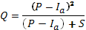 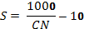 and

Q = runoff depth in inches of precipitation
P = total precipitation in inches from design storm, 4.6 or 5.5
Ia = initial abstraction; before runoff begins, 0.44
S = storage coefficient; potential maximum retention after runoff begins, in inches, 2.2
CN = curve number, 82

Q for a 25 yr storm = 2.72 inches of depth
Q for a 100 yr storm = 3.53 inches of depth

Q_{vol} = Total runoff volume is found by multiplying the watershed area by the depth. Q_{vol} = Q*(1 ft/12 in) *.16 sq. miles * (5280 ft/1mile)²
Q_{vol} = for a 25 yr storm = 1.01* 10⁶ ft³
Q_{vol} = for a 100 yr storm = 1.31* 10⁶ ft³

Peak runoff was calculated via the CN approach and synthetic triangular hydrograph. In order to determine the peak runoff from the total runoff volume a standard triangular synthetic hydrograph was developed which gave the relationship between total runoff volume and peak runoff as:
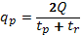 and

t_{c} = time of concentration, 25 mins
t_{p} = time to peak, 28 mins
t_{r} = time to recession, 42 mins
Q = runoff volume for a storm in ft³

q_{p} = peak runoff for a 25 yr storm = 454 ft³ /sec
q_{p} = peak runoff for a 100 yr storm = 588 ft³ /sec

THIS PAGE IS BLANK.
Table 3. Weighted Average Curve Number of the Watershed

Land Use | Percent of Watershed | Soil EbB HG C | Soil HwB HG C | Soil LaB HG C | Soil LtB HG C | Soil MaB HG C | Soil OaA HG C | Soil OrB HG C | Soil TeA HG D | CN with all soil types
Commercial:Retail | 3.61 | 94 | 94 | 94 | 94 | 94 | 94 | 94 | 95 | 94
Forest/Brush/Grass:Brush | 12.00 | 70 | 70 | 70 | 70 | 70 | 70 | 70 | 77 | 73
Forest/Brush/Grass:Deciduous | 8.78 | 73 | 73 | 73 | 73 | 73 | 73 | 73 | 79 | 75
Forest/Brush/Grass:Forest Plantation | 0.62 | 76 | 76 | 76 | 76 | 76 | 76 | 76 | 82 | 78
Forest/Brush/Grass:Grassland | 12.08 | 79 | 79 | 79 | 79 | 79 | 79 | 79 | 84 | 81
Forest/Brush/Grass:Mixed forest | 4.44 | 73 | 73 | 73 | 73 | 73 | 73 | 73 | 79 | 75
Impervious:Impervious | 5.74 | 98 | 98 | 98 | 98 | 98 | 98 | 98 | 98 | 98
Other:Disturbed Land | 0.03 | 91 | 91 | 91 | 91 | 91 | 91 | 91 | 94 | 92
Public/Private/Institutional:Educational | 0.88 | 86 | 86 | 86 | 86 | 86 | 86 | 86 | 89 | 87
Public/Private/Institutional:Health facilities | 0.68 | 86 | 86 | 86 | 86 | 86 | 86 | 86 | 89 | 87
Residential:High density residential | 10.44 | 90 | 90 | 90 | 90 | 90 | 90 | 90 | 92 | 91
Residential:Low density | 10.71 | 79 | 79 | 79 | 79 | 79 | 79 | 79 | 84 | 81
Residential:Medium density | 28.51 | 81 | 81 | 81 | 81 | 81 | 81 | 81 | 86 | 83
Water/Wetlands:Natural Lake/Pond | 0.86 | 100 | 100 | 100 | 100 | 100 | 100 | 100 | 100 | 100
Water/Wetlands:Wooded Wetland | 0.62 | 73 | 73 | 73 | 73 | 73 | 73 | 73 | 84 | 77
 |  |  |  |  |  |  | Watershed Total CN = |  |  | 82.0

Note: Each of the CN numbers came from the TR-55 and used a fair condition assessment for each hydrologic group.

Table 4. This table describes details of land use categories with their respective acres and percent of watershed.

Landuse Category : Description | Acres | Percent | Detailed Landuse Description
Commercial:Retail | 3.68 | 3.61 | Commercial areas along roadways not associated with distinct commercial centers or large shopping malls. Will include linear highway corridor development, as well as individual retail businesses and services that may exist within residential or industrial
Forest/Brush/Grass:Brush | 12.22 | 12.00 | Areas that have considerable growth of shrubs and small trees, but can not be classified as forest. The brush land cover must occupy at least 80% of the delineated area. Forest and grassland may be incorporated into the remaining 20%.
Forest/Brush/Grass:Deciduous | 8.94 | 8.78 | Forested areas where broadleaf trees make up at least 80% of the tree cover.
Forest/Brush/Grass:Forest Plantation | 0.63 | 0.62 | Rows of mature trees, primarily conifers, planted by man
Forest/Brush/Grass:Grassland | 12.30 | 12.08 | Open grassy areas with no associated adjacent land uses. May include small amounts of shrubs, trees and brush. The grassland cover must occupy at least 80% of the delineated area. The remaining 20% may be trees, shrubs and brush. Grassland areas may be
Forest/Brush/Grass:Mixed forest | 4.52 | 4.44 | Forested areas with mixed coniferous and deciduous trees. The ratio of the predominant coniferous or deciduous tree stands must not exceed 80%.
Impervious:Impervious | 5.85 | 5.74 | Comprised of more than 90% impervious surfaces
Other: Disturbed Land | 0.03 | 0.03 | Land that has been cleared of vegetation and the interpretation of any identifiable or defined land use class is not possible.
Public/Private/Institutional: Educational | 0.89 | 0.88 | All schools, university and college academic buildings, research facilities, and associated parking facilities and quads. College campuses include other land uses that, if at least one-half acre in area, will be designated as distinct LULC classes. Pe wi
Public/Private/Institutional: Health facilities | 0.69 | 0.68 | Hospital, health clinics, medical offices, and nursing homes.
Residential: High density residential | 10.63 | 10.44 | Residential land areas with approximately 5 or more dwellings on average per acre. Comprised mainly of urban areas of residential land use patterns including densities ranging from single family structures to multi-unit apartment buildings.
Residential:Low density | 10.91 | 10.71 | Residential land areas with a maximum average of 1 dwelling per acre.
Residential: Medium density | 29.04 | 28.51 | Residential land areas with more than 1, but less than 5 dwellings on average per acre.
Water/Wetlands: Natural Lake/Pond | 0.88 | 0.86 | Bodies of water that are not formed by damming creeks. Ponds may be man-made.
Water/Wetlands: Wooded Wetland | 0.63 | 0.62 | Wooded areas that show considerable amounts of water beneath the trees.

Appendix 2. Existing Watershed Structures from Upstream to Downstream.

- 3’, Corrugated Metal Culvert, Round (conveys flow from NYS DOT Rt. 96B)
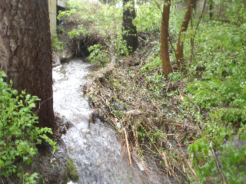

- Open Swale, Grass & Gravel
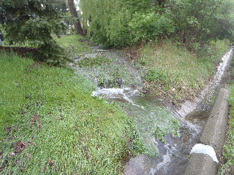

- Curved Concrete Lined Channel, 2.5’w x .5’h
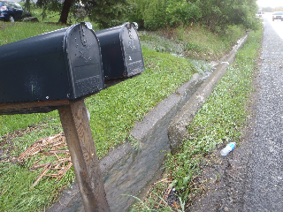

- 2.5’, Corrugated Metal Culvert, Oval
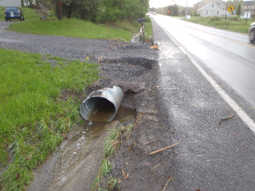

- Curved Concrete Lined Channel, 2.5’w x .5’h
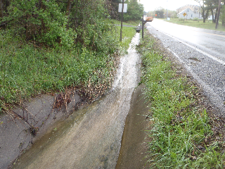

- Concrete Lined Channel, 4’w x 7’w x 1.5’h
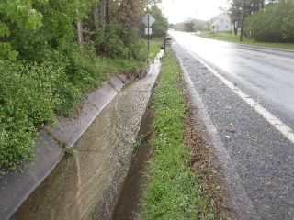

- 2.5’, Corrugated Metal Culvert, Oval

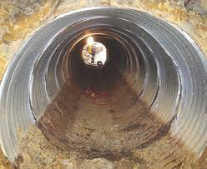

- Concrete Lined Channel, 4’w x 7’w x 1.5’h
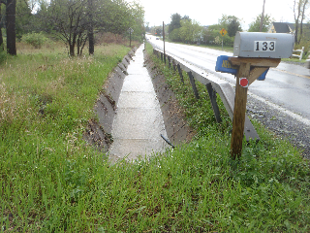

- 2.5’, High Density Polyethylene Culvert, Round
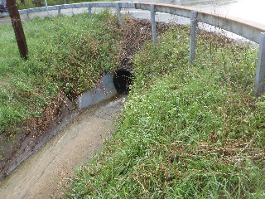

- Concrete Lined Channel, 4’w x 6’w x 1.7’h
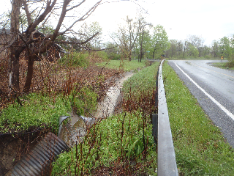

- Outlet into Gorge, 3’ Corrugated Metal Culvert, Round
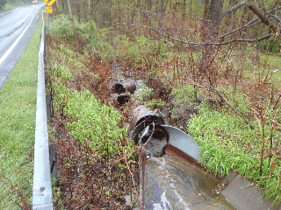

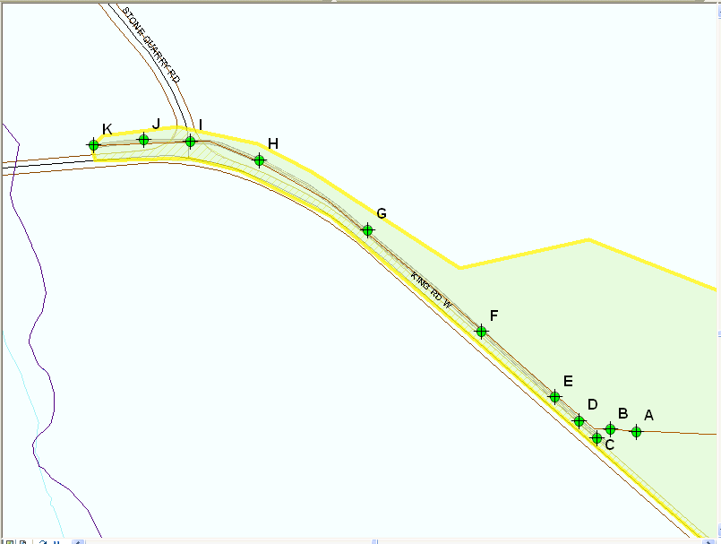
Figure 1A. Displays the location of each stormwater structure detailed above.
Appendix 3. Solution#1: Weir & Armored Channel

Design Area: Current Weir Capacity
The current weir capacity is based upon using the existing trapezoidal, concrete lined-channel as the rectangular weir.

Channel Dimensions & Calculations using Manning’s equation:
Q = V*A
V= (1/n)* R^{2/3}*S^{1/2}

Q=Maximum Flow, CFS
V=Velocity, Ft/sec
A= Cross-sectional area, Ft², 8.5
Wetted Perimeter= Perimeter of the channel, 13.4’
R= Cross-sectional Radius =A/Wetted Perimeter, 0.63
S= Slope, 0.06 for this channel
Channel Length = 139’, Depth = 1.7’,
Bottom Width = 4’, Top Width = 6’

Q = 100.36 CFS, ~ 100 CFS
V = 11.8 Ft/sec, ~ 12 Ft/sec

Weir calculations check based upon Isco Flow metering Book of Weir Coefficients:
L=h+v²/(2g)
L= Length of opening in weir
h= height of , water in weir @ supercritical flow, 1.7’
v= velocity of water, 11.8 Ft/sec
g= gravity, 32.174 Ft²/sec

L = 3.8’, ~ 4’ length of weir

From same source using weir coefficient for rectangular weir
Q = 13.32 L^{1.5}
Q= Max flow, 100 CF

L=3.8’, ~ 4’

Froude Number (Fr)
Fr = v/(SQRT(y*g))
v = velocity, Ft/sec, 11.8
y = cross-sectional area / top width of weir, 1.4
g= gravity, 32.174 Ft²/sec

Fr = 1.74
If Fr <= 2.5, then use energy dissipation via a hydraulic jump using basin Type 1. True (1.7)
Therefore line channel length >=6y2 with rip rap.
y2 = y1/2 *(SQRT(1+8Fr²)-1)
y2 = flow depth after energy dissipation
Y1 = flow depth entering energy dissipation, 1.7’
Fr = 1.7

y2 = 3.43’
6*y2 = 20.6’ Based upon US Bureau of Reclamation’s (USBR) Design of Small Dams 1977.
NYS DEC Stormwater Manual recommends lining the basin at least 80’ based upon Figure 5B.13 from the NYS Standards and Specifications for Erosion and Sediment Control. This figure from the manual uses tailwater condition >= 0.5 outlet diameter. Figure 5B.14 and 5B15 are included below to detail specific install guidelines of rip rap. The dMax of the rip rap recommended comes from the table on Page 5B.18 which says that 12 Ft/sec velocity needs d50 of 24 inches. Minimum depth of rip rap is the maximum depth of flow; 3.4’ Side slopes are 2:1 ratio with dmax = 18 inches.

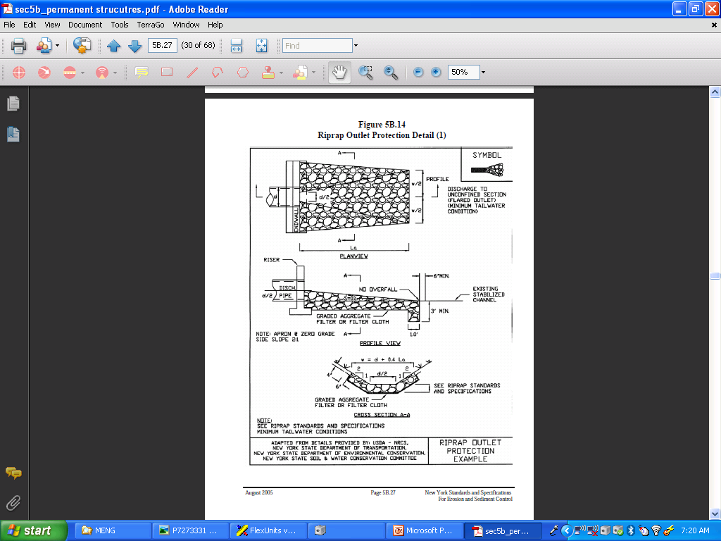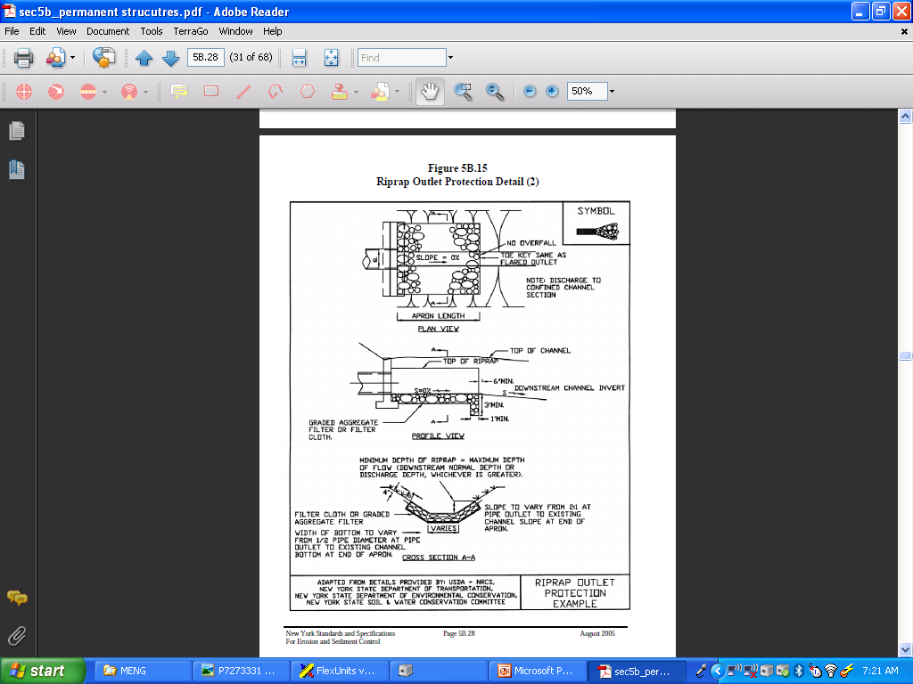

Appendix 4. Solution#2: Catchbasin Inlet & piped

Design Area: New inlet catchbasin
New catchbasin inlet dimensions & calculations using Manning’s equation; the catchbasin is acting like a culvert:
Q = (A* SQRT (2gh))/(SQRT((Kc*L*Ke + 1)))

Q=Maximum Flow, CFS,
A= Cross-sectional area, Ft² , 4’ Diameter, A = Pi()r², Pi()2² , 12.56
g= gravity, 32.174 Ft²/sec
h = 0.6*Diameter, 2.4’
Kc = .004 from USBR table
L = Length of culvert, 4’
K3 = 0.5 from USBR table

Q = 126.8 CFS going into inlet

Velocity of water inside of catchbasin
V = Q/A

Q = 126.8 CFS
A= Cross-sectional area, Ft² , 4’ Diameter, A = Pi()r², Pi()2² , 12.56

V=Velocity, Ft/sec, 10.1

Design Area: New HDPE culvert pipes to connect catchbasins and outlet
Q = (A* SQRT (2gh))/(SQRT((Kc*L*Ke + 1)))

Q=Maximum Flow, CFS,
A= Cross-sectional area, Ft² , 3’ Diameter, A = Pi()r², Pi()2² , 7.07
g= gravity, 32.174 Ft²/sec
h = 0.6*Diameter, 1.8’
Kc = .0002 from USBR table
L = Average length of culvert, 45’
K3 = 0.5 from USBR table

Q = 61.9 CFS going into catchbasin & outlet

Velocity of water inside of pipes
V = Q/A

Q = 61.9 CFS
A= Cross-sectional area, Ft² , 4’ Diameter, A = Pi()r², Pi()2² , 7.07

V=Velocity, Ft/sec, 8.76

Additional rip rap channel located above pipes. For rip rap sizing see NYS DEC Stormwater Manual and Appendix 3 for excerpts from the manual.

Appendix 5. Cost Comparison of Previous Drainage Projects:

Town of Ithaca work crews completed all the site work and installation on many stormwater projects. Within the past year, there were 2 similar drainage projects completed when compared to the current design area: Elm St Extension and Old Gorge Rd.

Elm St Extension:
Site Description: Needed to stabilize undermining of road base and ditch erosion on a rural, steep hill slope. Average slope was 20% and included asphalt repair.

Site Design Plan Summary: Used 5 catchbasins and 400’ of 15” HDPE pipes to convey stormwater into rip rap energy dissipation basin at the outlet. Total Project Cost $33,786.
Site cost per Linear Foot of drainage installed: $84 per LF

Old Gorge Rd:
Site Description: Needed to stabilize earthen ditch line and road undermining on a moderate slope in a residential community. Average slope was 15% and included some asphalt repair.
Site Design Plan Summary: Used 2 catchbasins, 350’ of rip rap lined channels, and an energy dissipation basin at the outlet. Total Project Cost $61,200.
Site cost per Linear Foot of drainage installed: $176 per LF

SCS. 1986. Urban Hydrology for Small Watersheds, Technical Release-55 (TR-55). USDA.

